CPS Theory Assignment 4
Group Members:
- Arham Hussain (22k-4080)
- Hateem Siddiqui (22k-8701)
- Yasir Chandio(22k-4089)
- Aarib Ahmed(22k-4004)
- Masir Ali Khan(22k-8702)
- Zamin Khan(22k-4104)

Q1:
- I have put in a lot of effort to ensure that I was able to secure the best deal possible for you. I hope that you are happy with the outcome, and if there is anything else I can do to assist you, please do not hesitate to let me know.
- Dear Arham, we wanted to inform you that we have reviewed your Visa Gold Card account and have decided to adjust your credit limit. Your new limit will be $5,000. We understand this may be a change from your previous limit, but we believe this adjustment is in your best interest and will help ensure responsible use of credit. If you have any questions or concerns, please don't hesitate to contact us.
- Dear Mr. Jones, it is my pleasure to inform you that your loan application has been approved. We appreciate the opportunity to assist you in meeting your financial needs. We will be reaching out to you shortly with more details on your approved loan amount, terms, and repayment schedule. Thank you for choosing our organization for your financial needs. We look forward to working with you.
- I am happy to inform you that your request to use the conference room on Wednesday 13th, 11:00 pm has been approved. We are pleased to be able to accommodate your needs and hope that the conference room will meet your requirements.
- I wanted to follow up with you regarding the updated company policy that we discussed. Please find attached a copy of the revised policy for your convenience. We have made some changes to the policy to better reflect our commitment to fairness and transparency. If you have any questions or concerns about the policy or how it may impact your work, please reach out to me or the accounts department.
- Dear Customer, it was a pleasure to serve you at JC, as a token of appreciation we have attached some discount coupons that you can avail next time you visit JC store. Thank you for your valuable interest in JC’s products.

Q2:
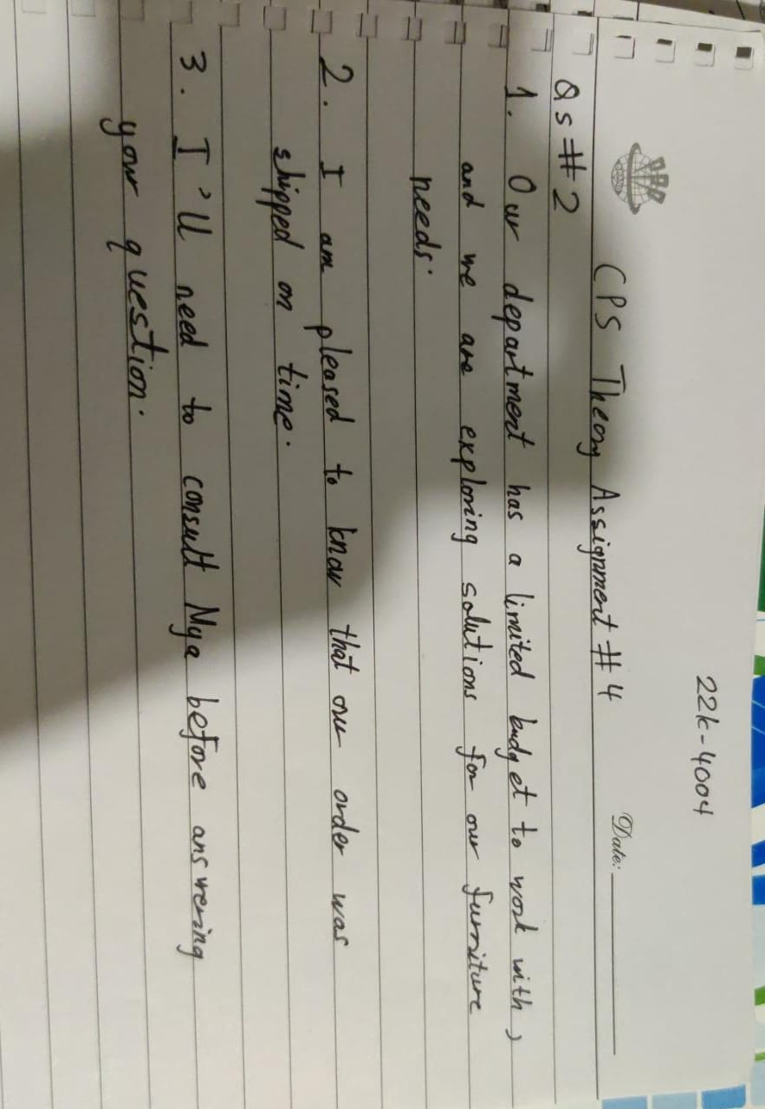

Q3:
- You'll be pleased to know that our new contract includes dental insurance as well.
- We are delighted to announce to you that deadline for the submission of proposal has been extended.
- I noticed that there are a few errors in your accounting report. Would you like some assistance in correcting them?
- In order to receive the materials, it is necessary for us to ensure that your cheque is cleared.
- To ensure that all members of our documentation group have access to the CAD-CAM computer lab during peak hours, we kindly request that you refrain from using the lab during those times. Thank you for your understanding and cooperation.

Q4:
Hello Karim
I hope you are well and reading my email. I want to draw your attention to a problem I've been having with our recent weekly meetings. I've seen that a few of your department's members have been monopolizing the conversations, so I haven't had a chance to offer updates on the work my team is doing.
I am aware that everyone's time is valuable and that our purpose in being here is to work efficiently. But I think it's crucial to guarantee that all teams get an equal chance to participate in these discussions. I respectfully ask you to let your department know about this issue and urge them to set aside time for other teams to present their progress.
I would be very grateful if I could set aside some time at the next meeting to talk about our updates, And I appreciate your understanding and look forward to working with you to create a more supportive and effective workplace.
Regards
(22k-4104)

Q5:
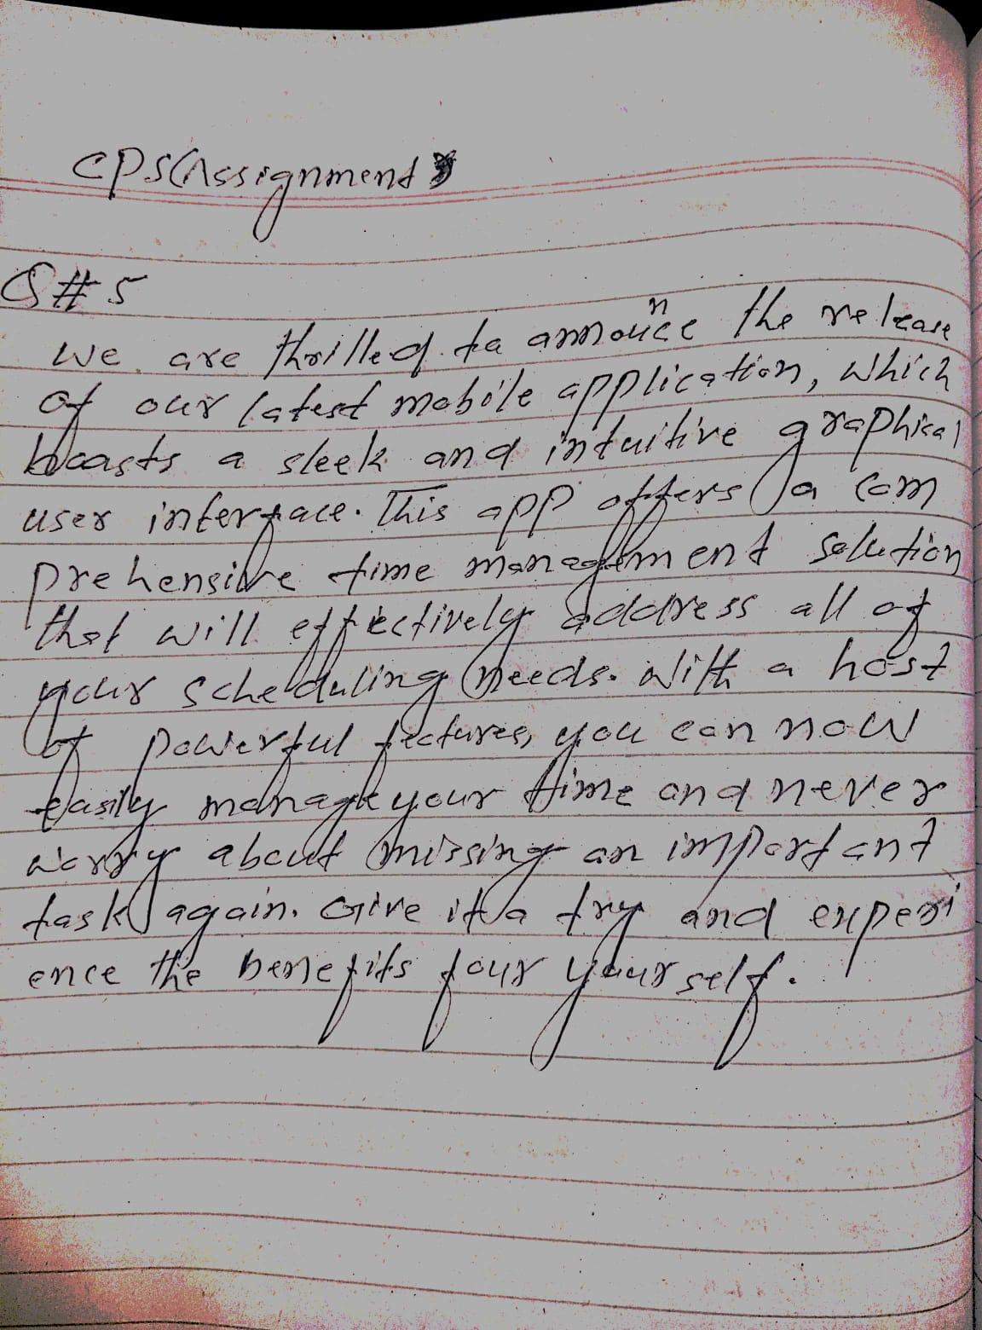

Q6:
- Looking for a budget-friendly way to experience the beauty of Alaska? Our local travel agency offers seven-day Alaskan cruises starting at just $1000 per person. These packages include accommodations, meals, excursions. With our knowledgeable guides and exceptional service, you can relax and enjoy all that Alaska has to offer without breaking the bank. Don't miss out on this amazing opportunity to explore one of the most breathtaking destinations in the world!
- I am pleased to report that the majority of students in Programming Fundamental Course performed exceptionally well on their final exam. Out of 120 students, 75% received a score of 1250-1300, indicating a deep understanding of the course material and mastery of the concepts covered throughout the semester.
- This smartphone is equipped with a vast range of applications designed to meet the diverse needs and interests of our customers. From productivity tools like Discord and Microsoft Office to entertainment apps like YouTube and Spotify, our phone has something for everyone.
- I'm happy to report that we have made significant progress on the project since our last update. We have completed construction outline and marketing posters, which puts us on track to meet our timeline and deliverables.
- The actor has won 10 awards for their outstanding performances in a variety of productions. These awards include Oscar awards and Talent of the year, which recognize excellence in performance categories such as acting, directing, and screenwriting. The actor's remarkable talent and dedication to their craft have earned them a reputation as one of the most respected and admired figures in the entertainment industry.

